# TASK – 1 – Modelling of thermal resistance Rθjc

## Step1

Firstly, we add the Material from library to setup the boundary condition.

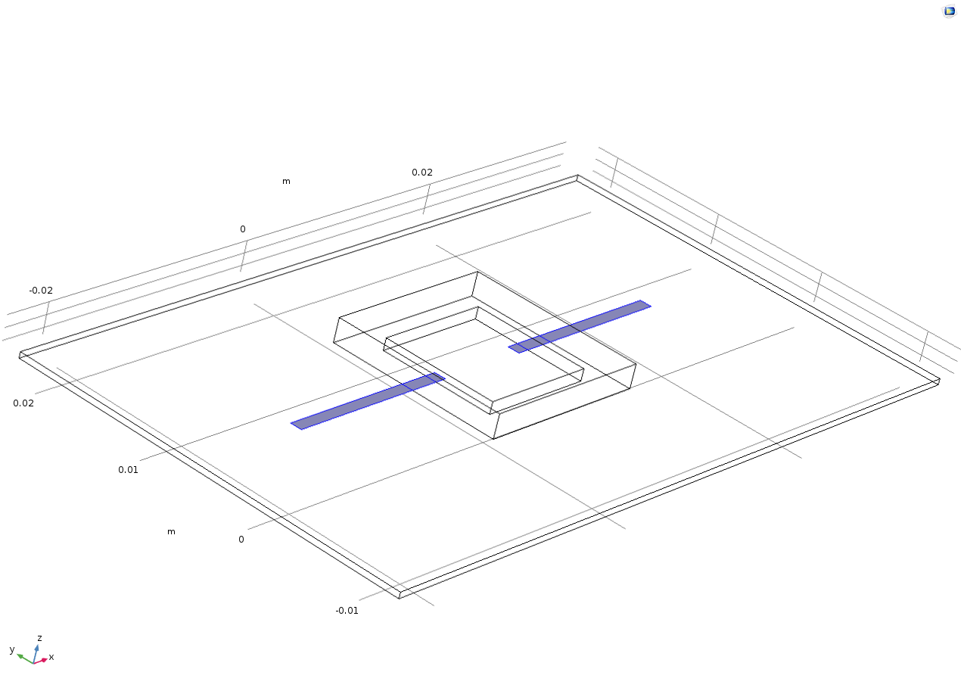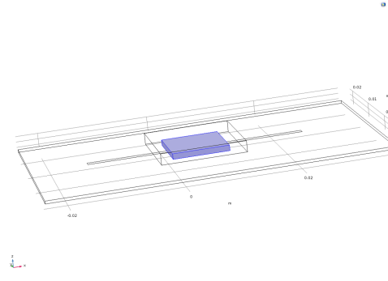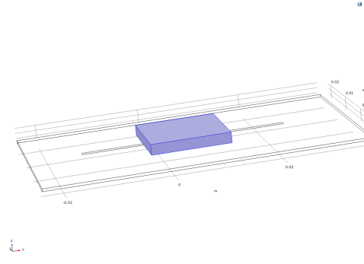

FR4(Circuit Board) Copper

Acrylic plastic Silica glass

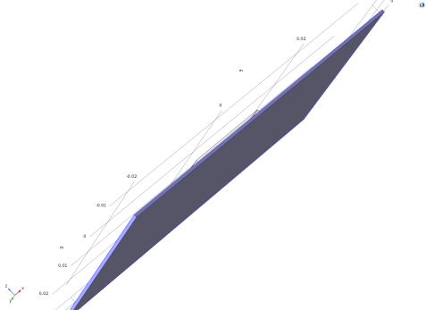

## Step2

We used the “Measure” function in Mesh menu to get the area and perimeter data to fill in Characteristic length window for both top and bottom sides.

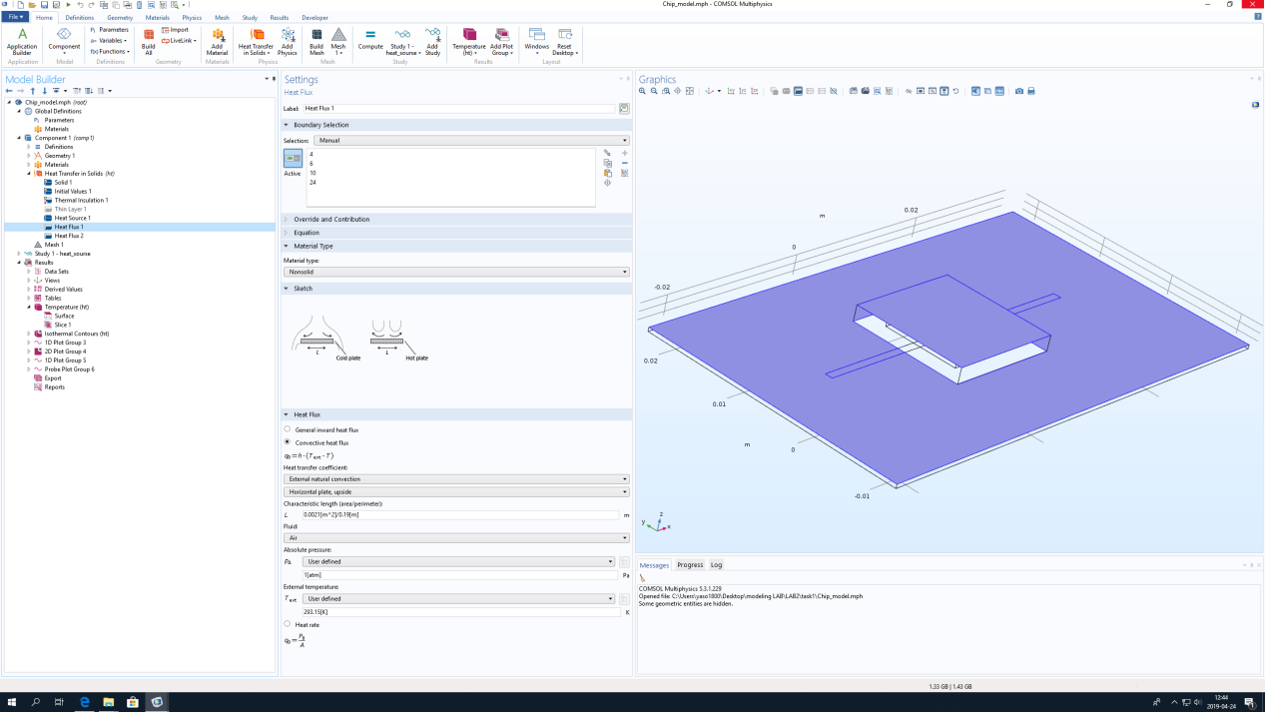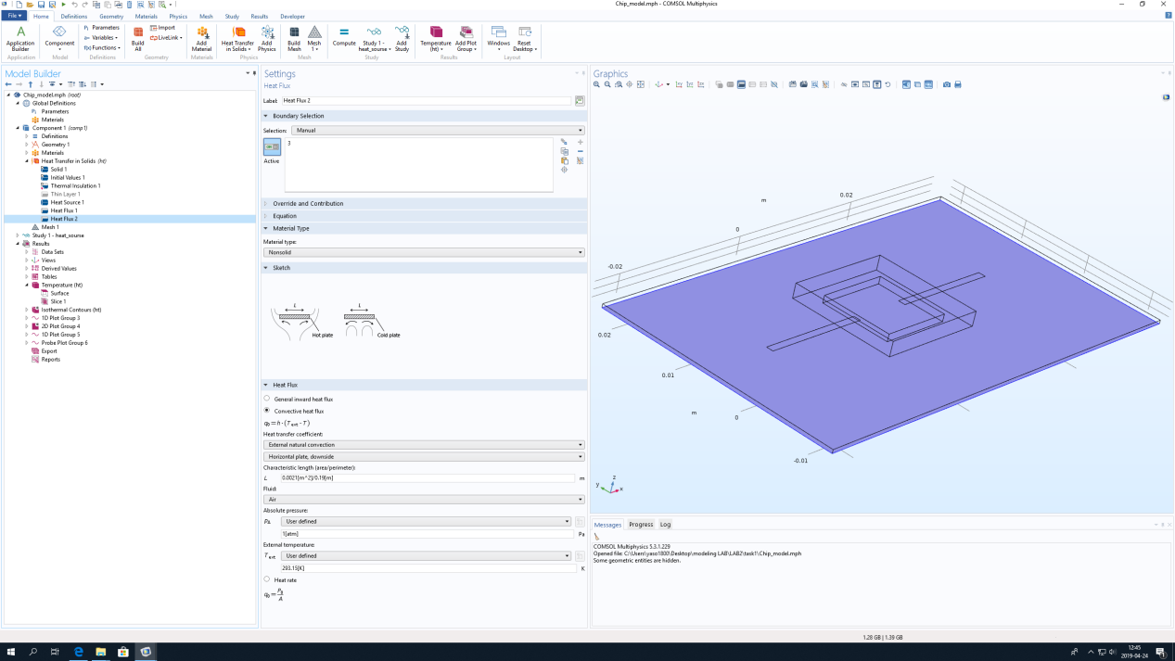

## Step3

We add an additional thermal contact boundary condition on between the IC chip and the component i.e. Rjc, with the value of 4.2 degC/W.

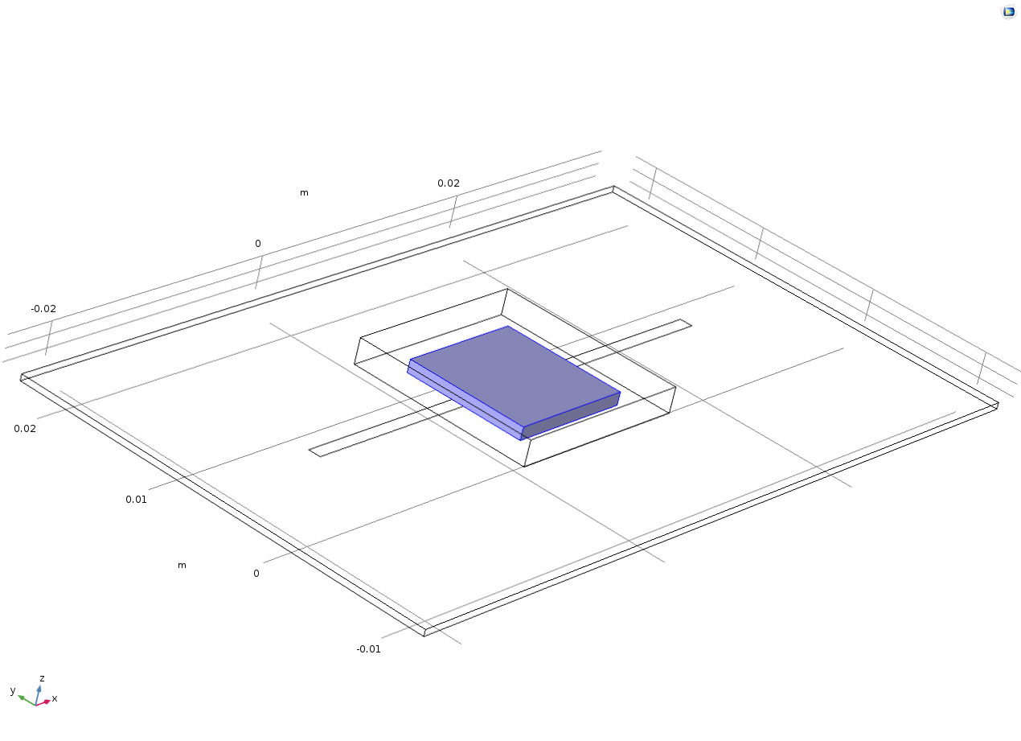

## Finally

We run the simulation with 0.5 W of heat source and 1 W of heat source combined with the “Use the cut line surface normal” function.

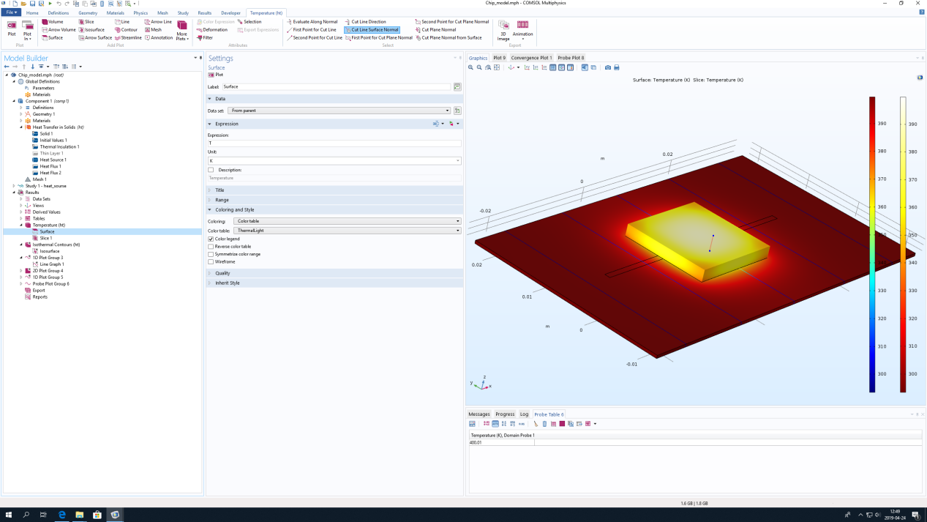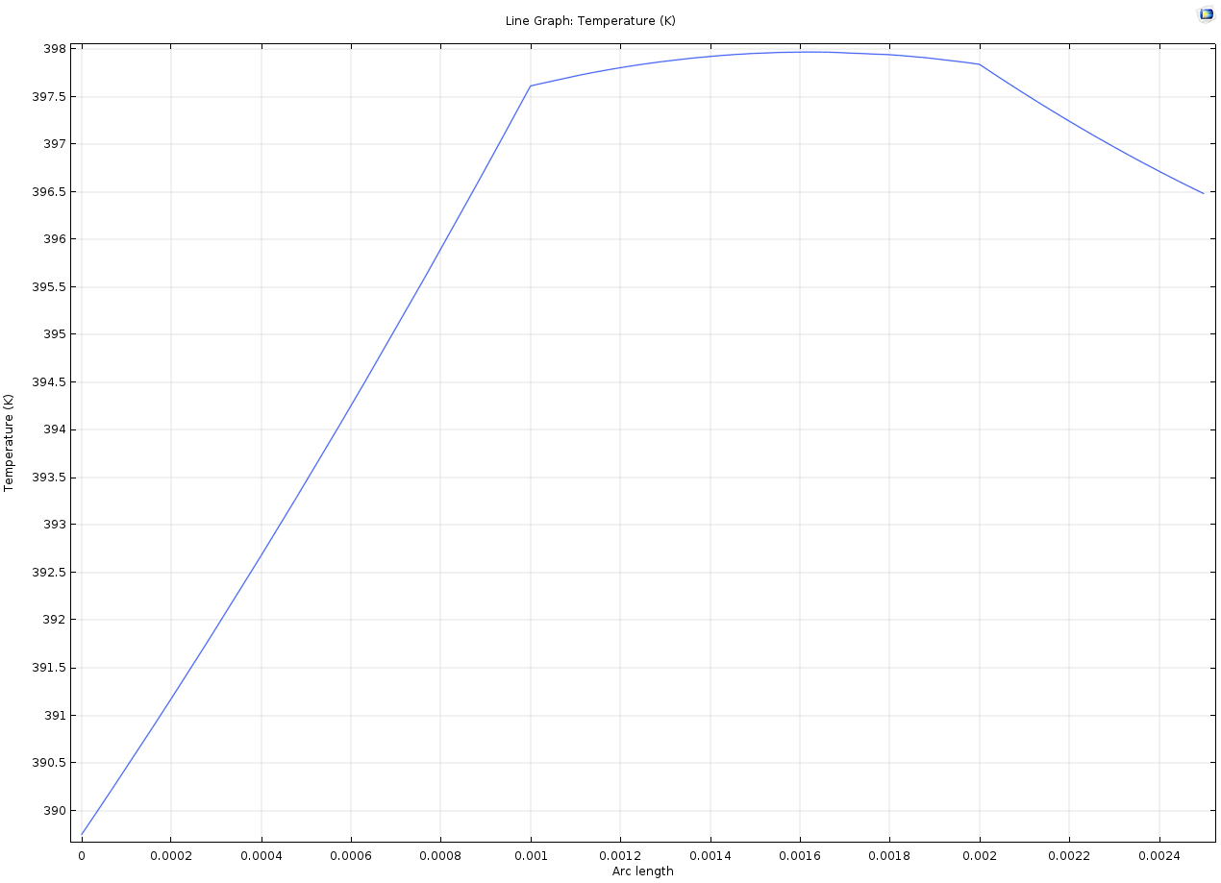

0.5w

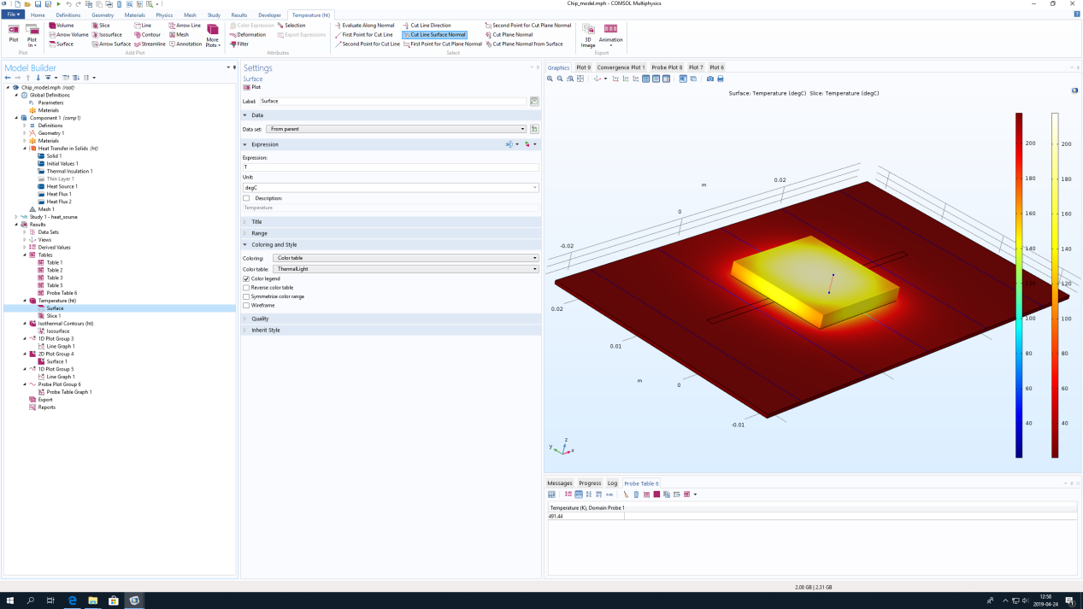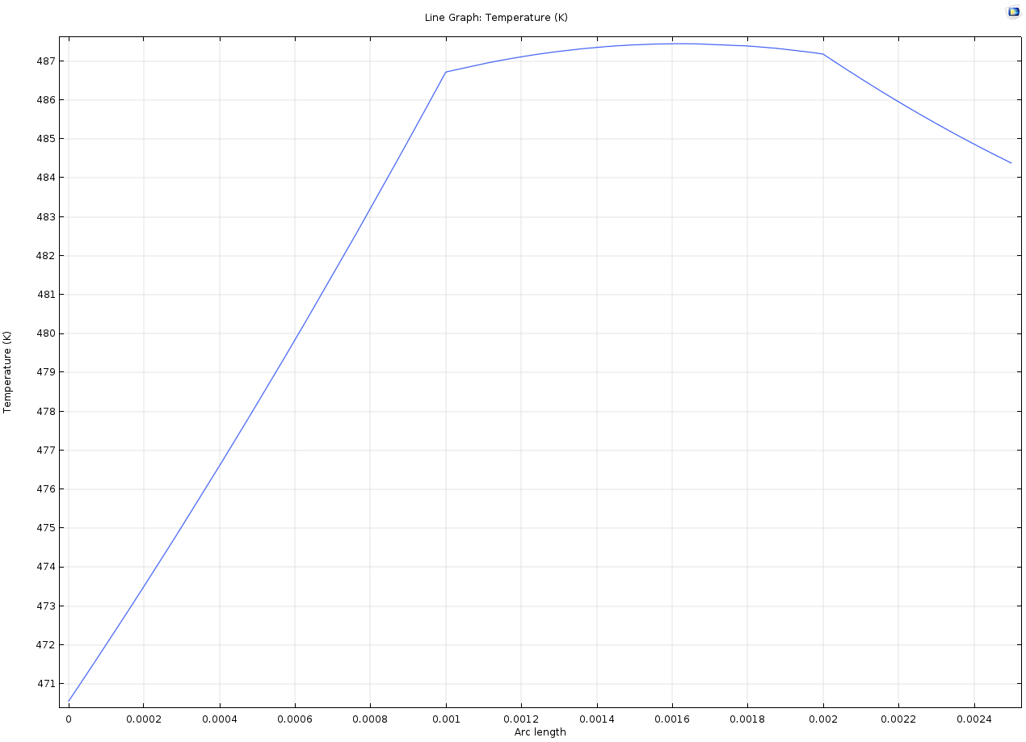

1W

According to the temperature maps and the line graph, we can see that:

When heat source is 0.5W, the maximum junction temperature rising to 400.01K at about 0.0015-0.0019 graph length.

When heat source is 1W, the maximum junction temperature rising to 491.44K at about 0.0014-0.0018 graph length.

Because the variables in our experiment are only heat source, so i think the more heat source we applied, the more junction temperature it will rise.

# TASK – 2 – Modelling of heat sink and resistances Rθch and Rθha/ Rθsa

## Step1

From the parameters list, we enabled the heat sink by setting the parameter to 1 from 0.

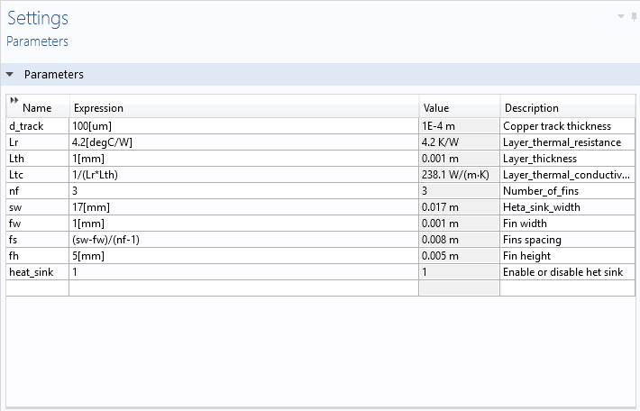

## Step2

After the heat sink is available select the material as aluminum for the heat sink.

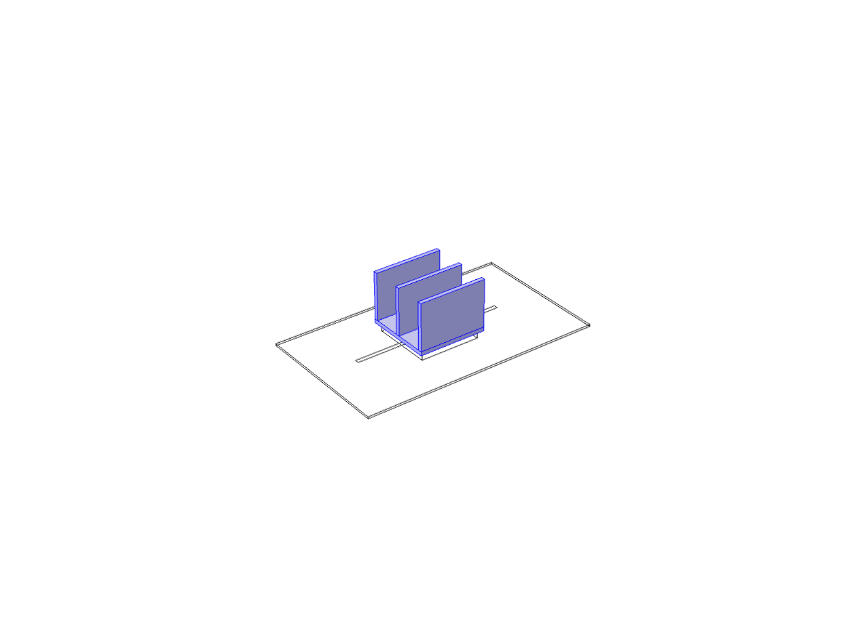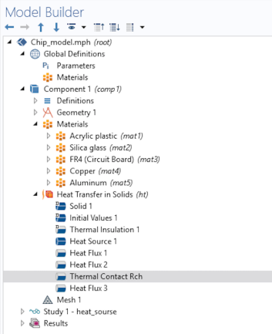

## Step3

After that, we selected a thermal contact between the surface of the heat sink and the IC and give the 5.5degC/W to it.

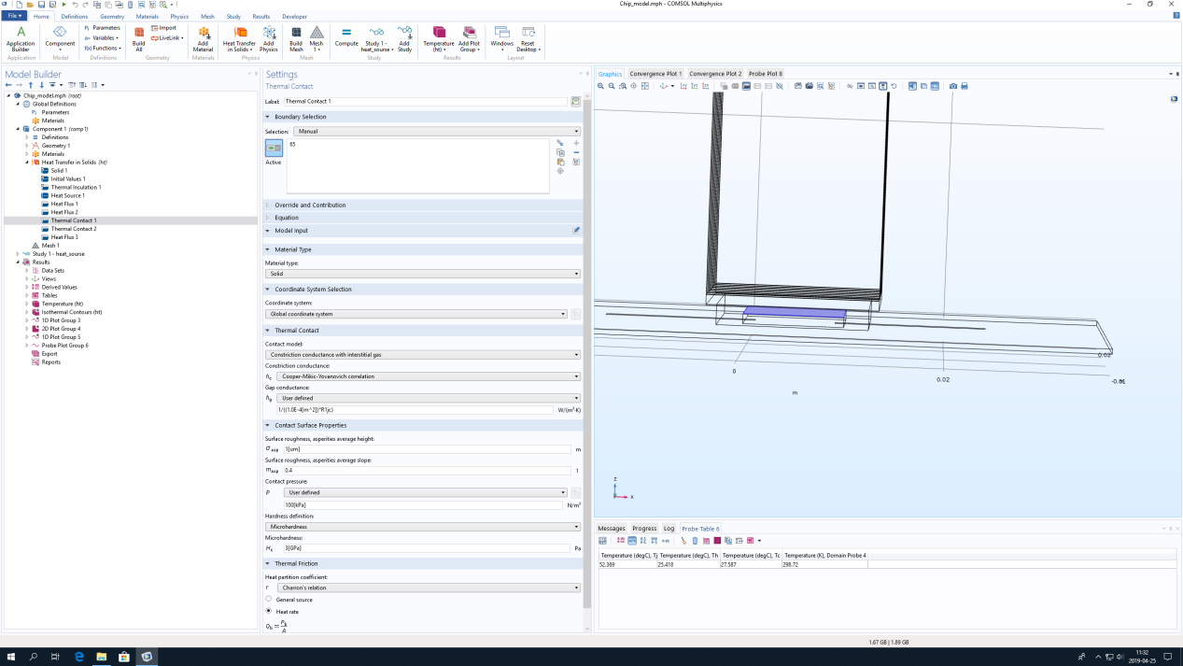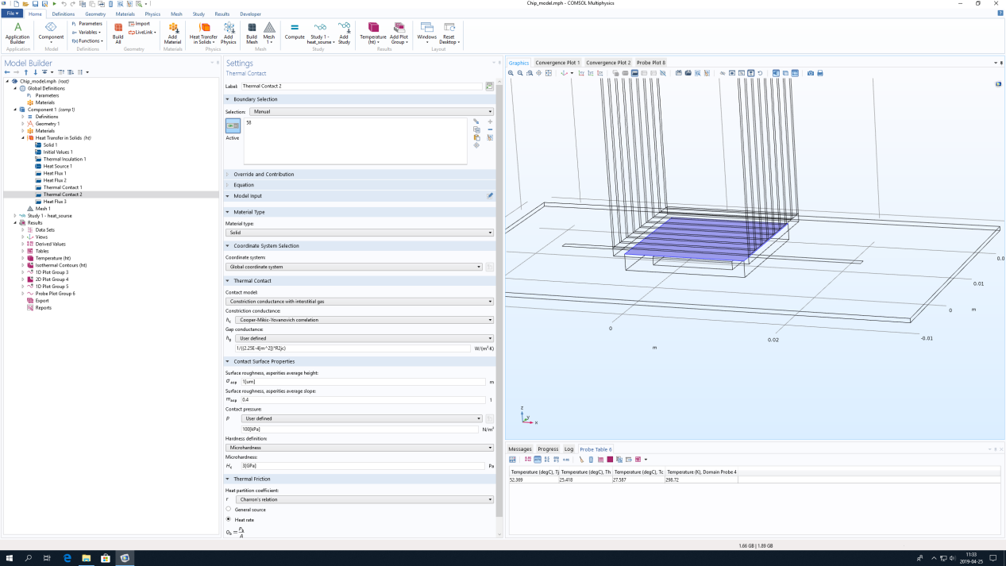

## Step4

For the heat sink select a heat flux boundary condition and select convective heat flux

and then user defined heat transfer coefficient of 5 W/m2.K.

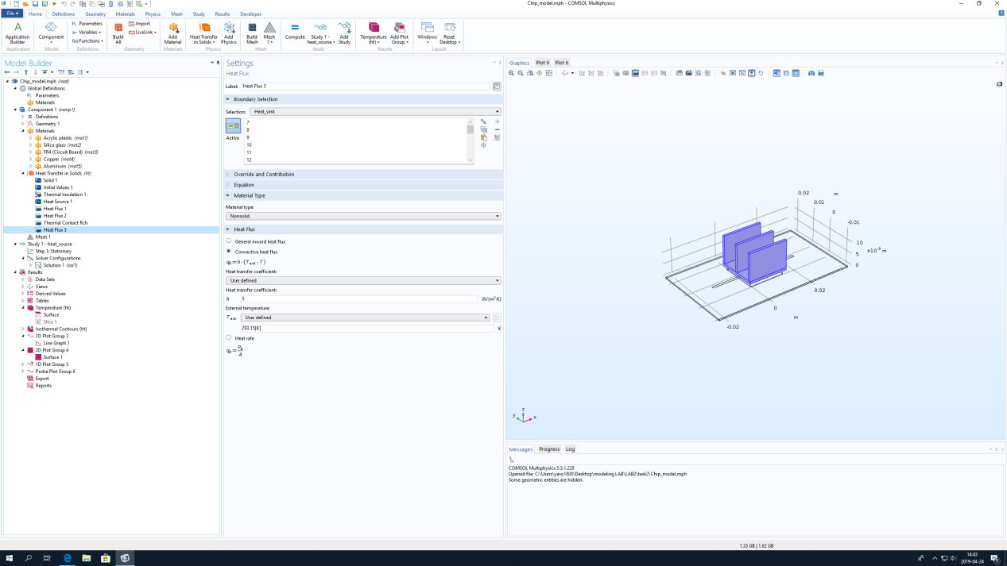

## Step5

Observe the temperatures Tj, Tc and Th in 0.5W and 1W.

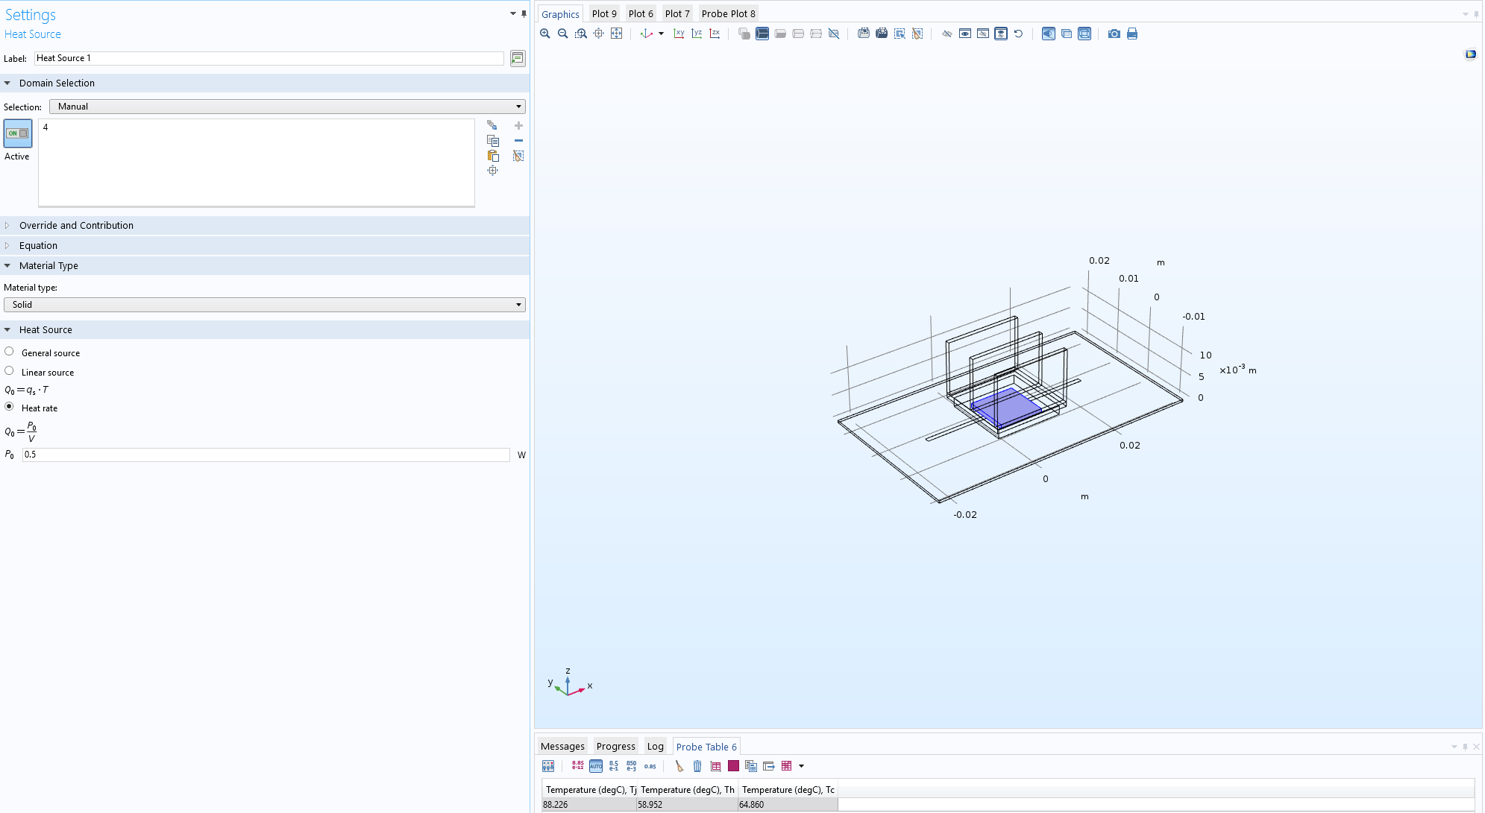

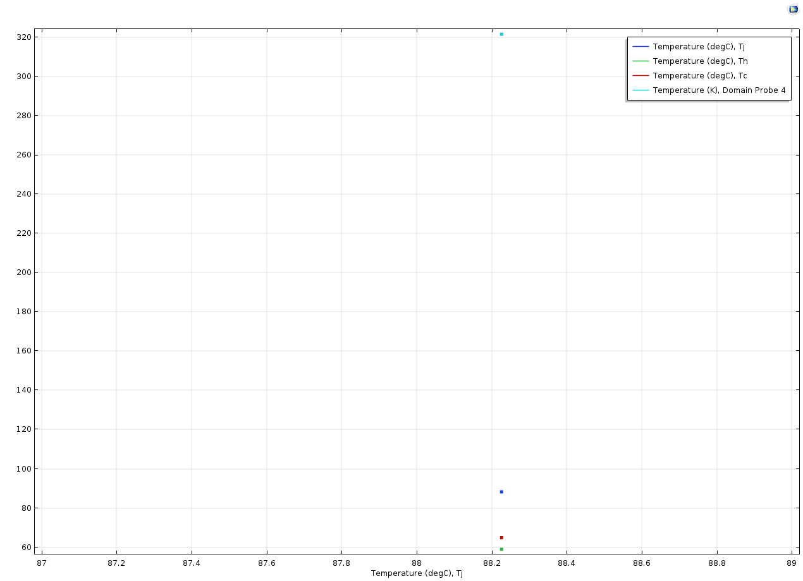

0.5W

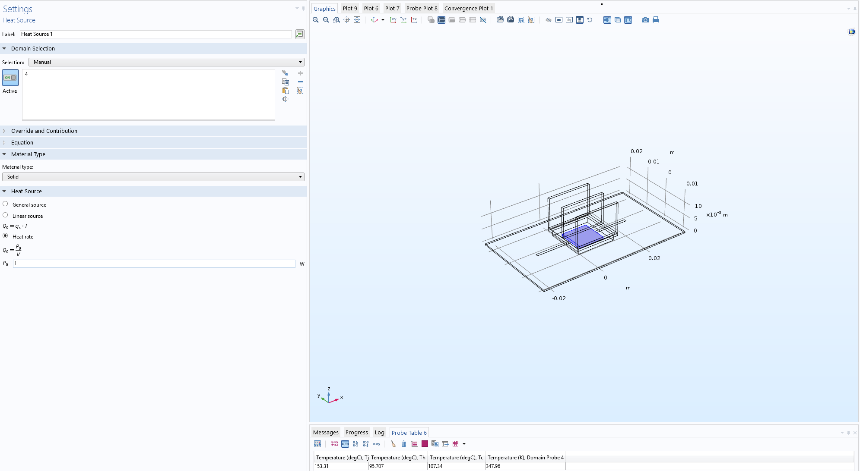

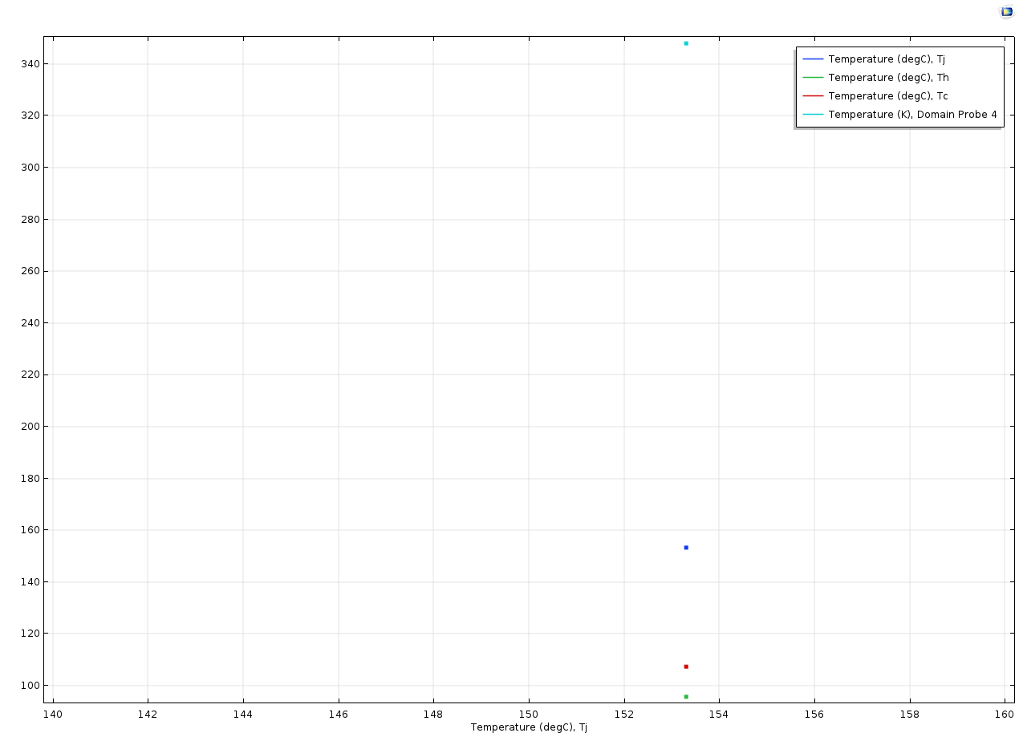

1W

## Step6

In last step, i measured hundreds groups of data and chose some Representative data to explain what we get.

|  |  |  |  |  |
| --- | --- | --- | --- | --- |
| sw | fw | nf | fh | line 1Tj |
| 17 | 0.5 | 5 | 5 | 74.84839987 |
| 17 | 0.5 | 7 | 5 | 69.14658607 |
| 17 | 1 | 3 | 5 | 83.96702183 |
| 17 | 1 | 5 | 5 | 74.29786663 |
| 17 | 1 | 7 | 5 | 68.65728546 |
| 17 | 1.5 | 3 | 5 | 83.40990887 |
| 17 | 1.5 | 5 | 5 | 73.79282448 |
| 17 | 1.5 | 7 | 5 | 68.21635665 |
| 17 | 2 | 3 | 5 | 82.87448473 |
| 17 | 2 | 5 | 5 | 73.31318134 |
| 17 | 2 | 7 | 5 | 67.80517558 |

|  |  |  |  |  |  |  |  |  |  |
| --- | --- | --- | --- | --- | --- | --- | --- | --- | --- |
| **sw** | **fw** | **nf** | **fh** | **Tj** | **sw** | **fw** | **nf** | **fh** | **Tj** |
| 17 | 0.5 | 3 | 5 | 84.56445516 | 17 | 0.5 | 21 | 5 | 56.24757452 |
| 17 | 0.5 | 3 | 5 | 84.56445502 | 17 | 0.5 | 21 | 5 | 56.24757452 |
| 17 | 0.5 | 3 | 15 | 73.35880675 | 17 | 0.5 | 21 | 15 | 52.50835617 |
| 17 | 0.5 | 3 | 25 | 67.51222876 | 17 | 0.5 | 21 | 25 | 51.03734394 |
| 17 | 0.5 | 3 | 35 | 63.97714189 | 17 | 0.5 | 21 | 35 | 50.25936758 |
| 17 | 0.5 | 3 | 45 | 61.63992832 | 17 | 0.5 | 21 | 45 | 49.78170609 |
| 17 | 0.5 | 3 | 55 | 60.00912359 | 17 | 0.5 | 21 | 55 | 49.46805874 |
| 17 | 0.5 | 9 | 5 | 65.39912445 | 17 | 0.5 | 27 | 5 | 54.42504633 |
| 17 | 0.5 | 9 | 5 | 65.39912446 | 17 | 0.5 | 27 | 5 | 54.42504688 |
| 17 | 0.5 | 9 | 15 | 58.42765412 | 17 | 0.5 | 27 | 15 | 51.43044554 |
| 17 | 0.5 | 9 | 25 | 55.43369818 | 17 | 0.5 | 27 | 25 | 50.2589458 |
| 17 | 0.5 | 9 | 35 | 53.7644895 | 17 | 0.5 | 27 | 35 | 49.64673024 |
| 17 | 0.5 | 9 | 45 | 52.74392135 | 17 | 0.5 | 27 | 45 | 49.26742521 |
| 17 | 0.5 | 9 | 55 | 52.05581927 | 17 | 0.5 | 27 | 55 | 49.01867085 |
| 17 | 0.5 | 15 | 5 | 59.26737662 | 17 | 0.5 | 33 | 5 | 53.24116909 |
| 17 | 0.5 | 15 | 5 | 59.26737661 | 17 | 0.5 | 33 | 5 | 53.24116932 |
| 17 | 0.5 | 15 | 15 | 54.37410304 | 17 | 0.5 | 33 | 15 | 50.72931106 |
| 17 | 0.5 | 15 | 25 | 52.40337197 | 17 | 0.5 | 33 | 25 | 49.75714275 |
| 17 | 0.5 | 15 | 35 | 51.34828826 | 17 | 0.5 | 33 | 35 | 49.24833828 |
| 17 | 0.5 | 15 | 45 | 50.6978017 | 17 | 0.5 | 33 | 45 | 48.93459369 |
| 17 | 0.5 | 15 | 55 | 50.26596077 | 17 | 0.5 | 33 | 55 | 48.7292353 |

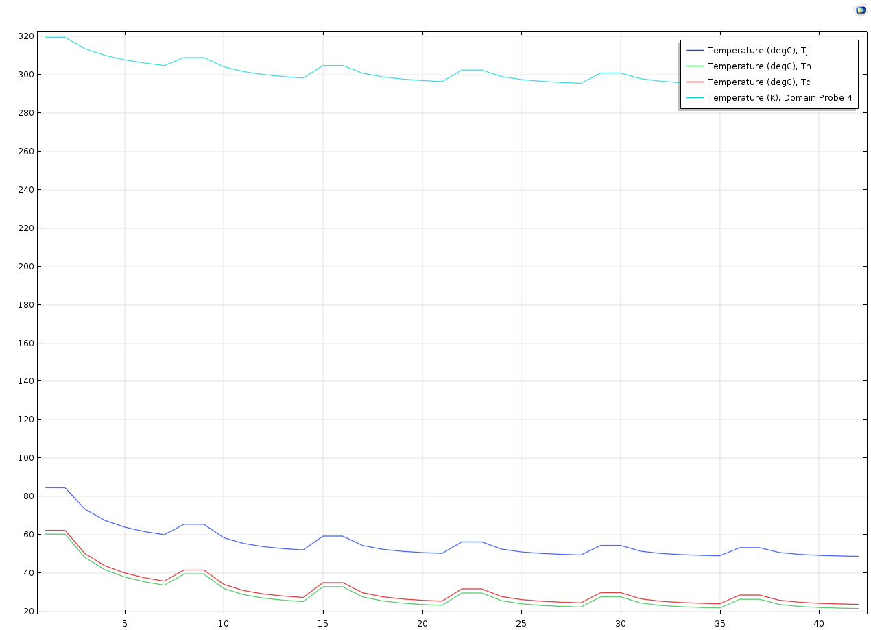

|  |  |  |  |  |
| --- | --- | --- | --- | --- |
| **sw(mm)** | **fw (mm)** | **nf** | **fh (mm)** | **Tj** |
| 17 | 0.5 | 33 | 5 | 53.239 |
| 17 | 1 | 17 | 5 | 92.941 |
| 17 | 2 | 8 | 5 | 65.852 |
| 17 | 3 | 6 | 5 | 92.945 |

Firstly, we defined that the sw equal to 17mm, so the number of fins times width of fin can not more than 17. In other words, number of fins can not increase unlimited.

As the red lines shown in form. If increased the fins indefinitely, it will lose the cooling function and bring an obviously temperature bound. when we fixed the height and width of the fins, the temperature will lower along with the number of fins raise.

For the height of fins, the temperature can be effectively cooled when it raised as much as possible. But this is only theoretically speaking, that’s mean it is also impossible to improve the height of fins without limited, we need to consider the external and the internal spaces limited and the material costs and so on.

Consequently, i think adjust both the number and height of fins can maximize the cooling effect. Because we have to apply this thing in reality, we can’t just adjust the value by infinity to achieve the expectation.